An Interview with our Spanish ”enforcement” Carlos Moreno:

- Hello Carlos, you are from Spain, live in Belgium and now you are in Kuopio. Could you tell us a bit more about yourself: how old are you? From where in Spain and where do you live in Belgium?
Hi! I'm a 25 years old PhD student in the University of Antwerp in Belgium. But as you said, I'm actually from Spain, from the city of Valencia.

- What are you doing in Kuopio? And how long are you staying?
I'll stay here for three months, doing an internship in the Pharmaceutical Sciences Faculty of the UEF as part of my PhD training.

- You have been in Luola training few times now. What do you think of it and club´s players?
First time I saw the entrance I thought I got the address wrong. But when I got in and I saw everyone playing table tennis I really loved it! The place is really cool and special. After learning that the translation of its name is "The cave" I understood it completely! In Spain is not common to have a place only for table tennis, where you can always leave the tables in position for training. I loved Luola!
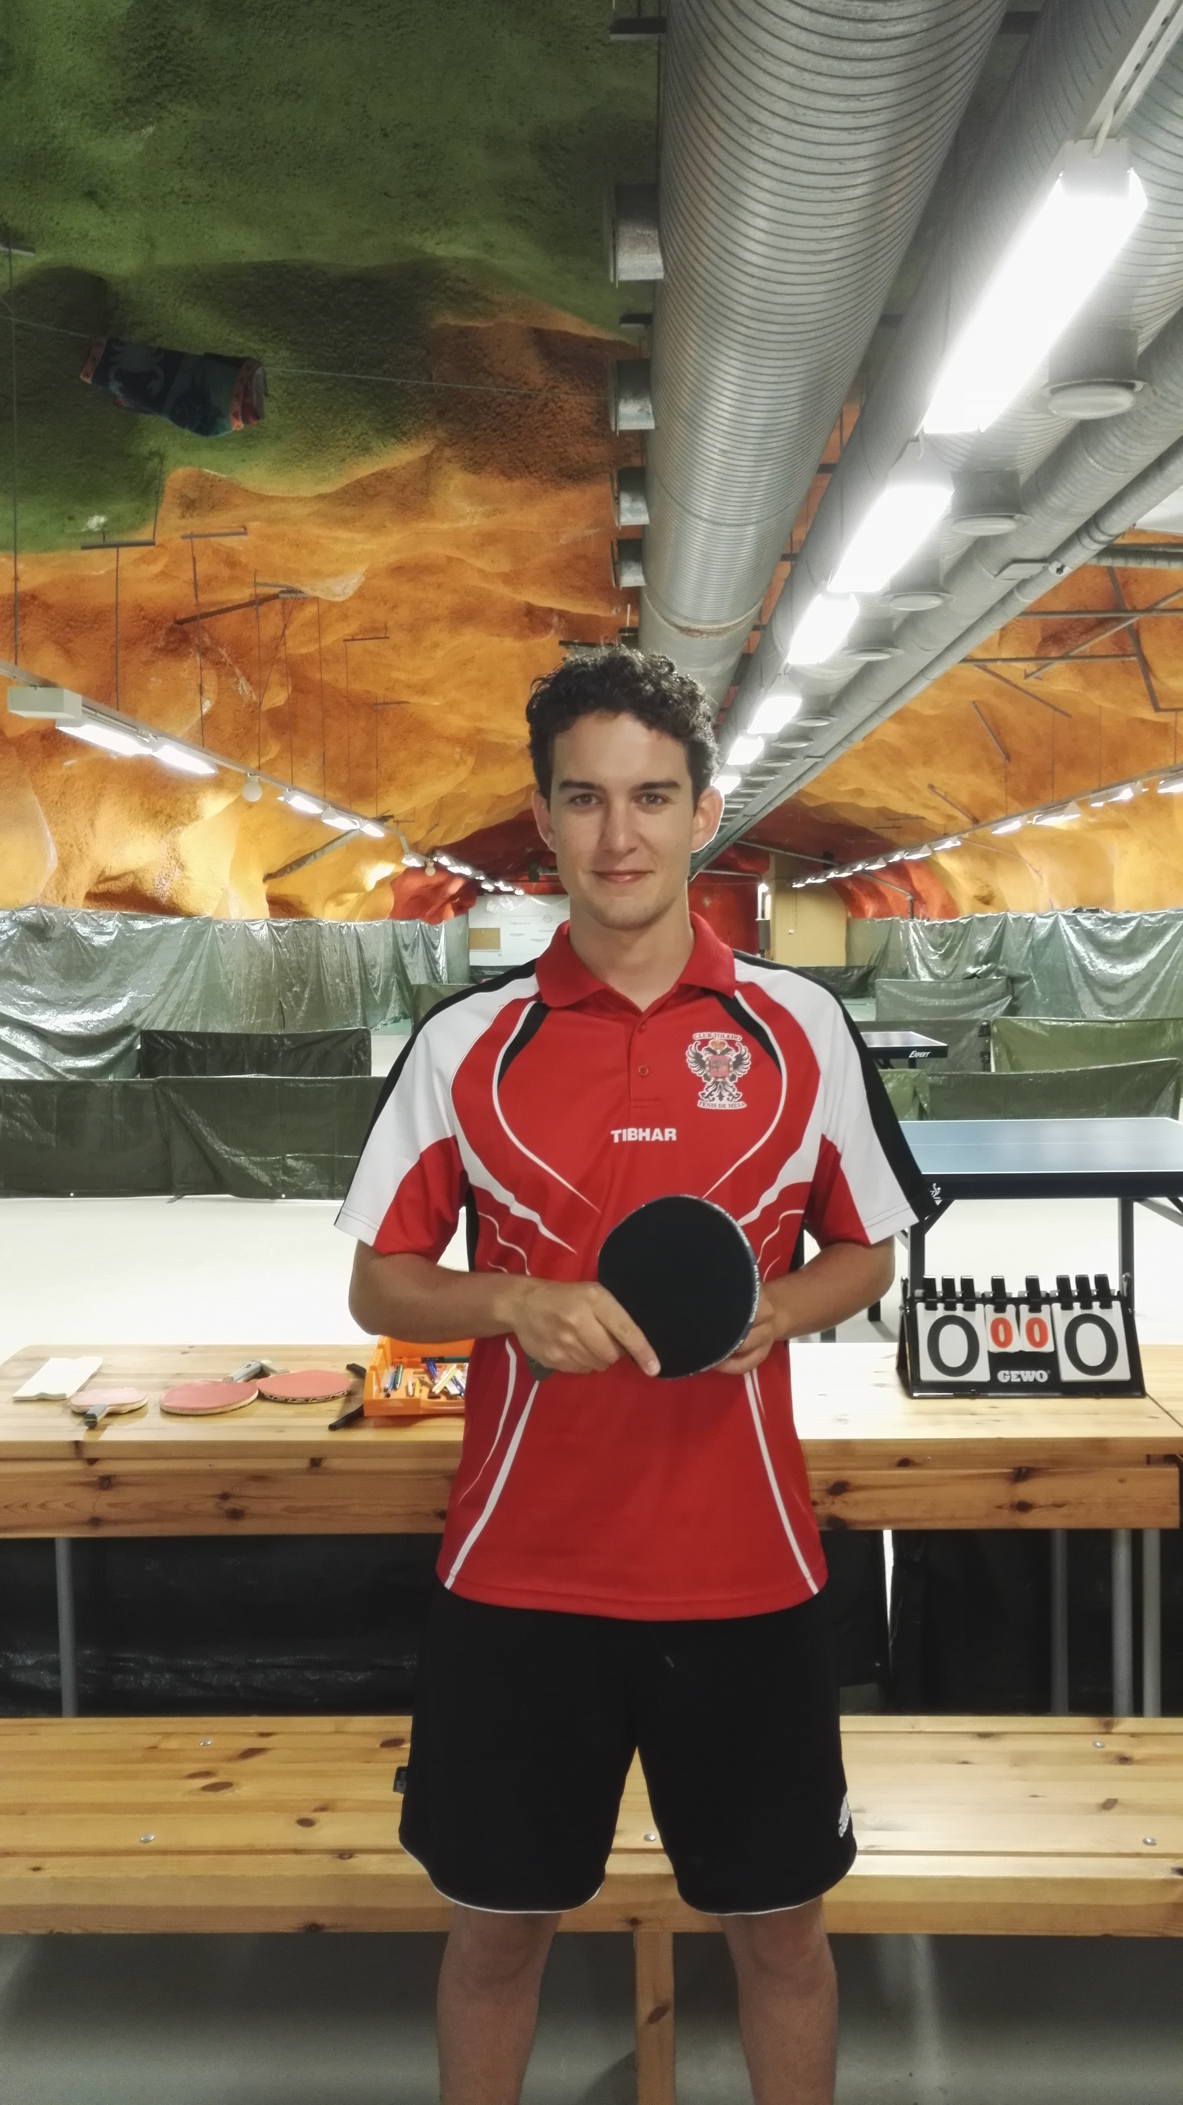
In the club I found more players than I expected for a city as big as Kuopio to be fair. And all of them (independently from their competition level) showed a high consistency in their game. I guess it's a good proof for the coaches doing some good job!

- What is your standard in Belgium? / Here in Finland we´ve got Rating-system. What is / would Your rating be in Belgium?
In Belgium we follow a pyramidal letter/number system who divides players in groups. Being A the top and smaller group (only 11 players, all professionals) and E the worst and biggest (2958 players). Also the number following will indicate your sub-group, being 0 the best and 6 the worst. In the VTTL Federation (only involving the Flemish part of Belgium) where I compete for Sokah Hoboken, my ranking this season will be C2.

So in summary, from the 8277 players federated I'd be between 510-791th best.

- When did you start playing table-tennis?
I started when I was 12. Before that I played football as a goalkeeper but due to an injury on my knee I was not allowed to play any contact sport before I got 18. Then I started with table tennis and I only stopped competing during the 5 years of my university studies.

- What are Your strengths / weaknesses in Your game?
Should I tell you? You will win me too easy now!

Probably my best stroke is forehand flat stroke and topspin. But in my game I think is more important the ability to read how the rival plays and adapt my game to it. I'm good at coming back during the games!

My weaknesses are mainly my service and my footwork. I'm too lazy!

- Who is the best table-tennis player / Your favourite player?

I think the best one all these moment is Ma Long with no doubt at all. However, I still admire Jan-Ove Waldner. He was a genius of this sport. He and Vladimir Samsonov are great examples of how technique can compensate the better physical conditions of younger players and still allow you to compete in a top class level surrounding the 40s.
- What rubbers / blade are You using?

My blade is a DONIC Persson Impuls 7.0. It's a very rigid offensive bat, with a really characteristic shape.

For the rubbers I've used Butterfly Tenergy 05 until they decided to get crazy with their price. Now I'm using XIOM Sigma Pro for the backhand and XIOM Omega Pro for my forehand. I'm specially happy with Sigma!

- Being a Spaniard, You must have a favourite football team. Is it Real Madrid, Barça, or?

It's Valencia FC of course! And the 2nd choice would be Atletico Madrid. But in Spain we all have our preference between Madrid and Barça, and if I have to choose I'd support Barcelona with no doubt!

